If you’re doing an **HVAC takeoff for a real estimate (not a napkin guess)**, you need to capture enough detail that pricing, labor, and scope gaps don’t ambush you later. This is where most estimates go to die.

Below is the **clean, professional checklist** used by competent HVAC estimators—and yes, skipping any of these will come back to bite.

**1. Project & Plan Information (Non-Negotiable)**

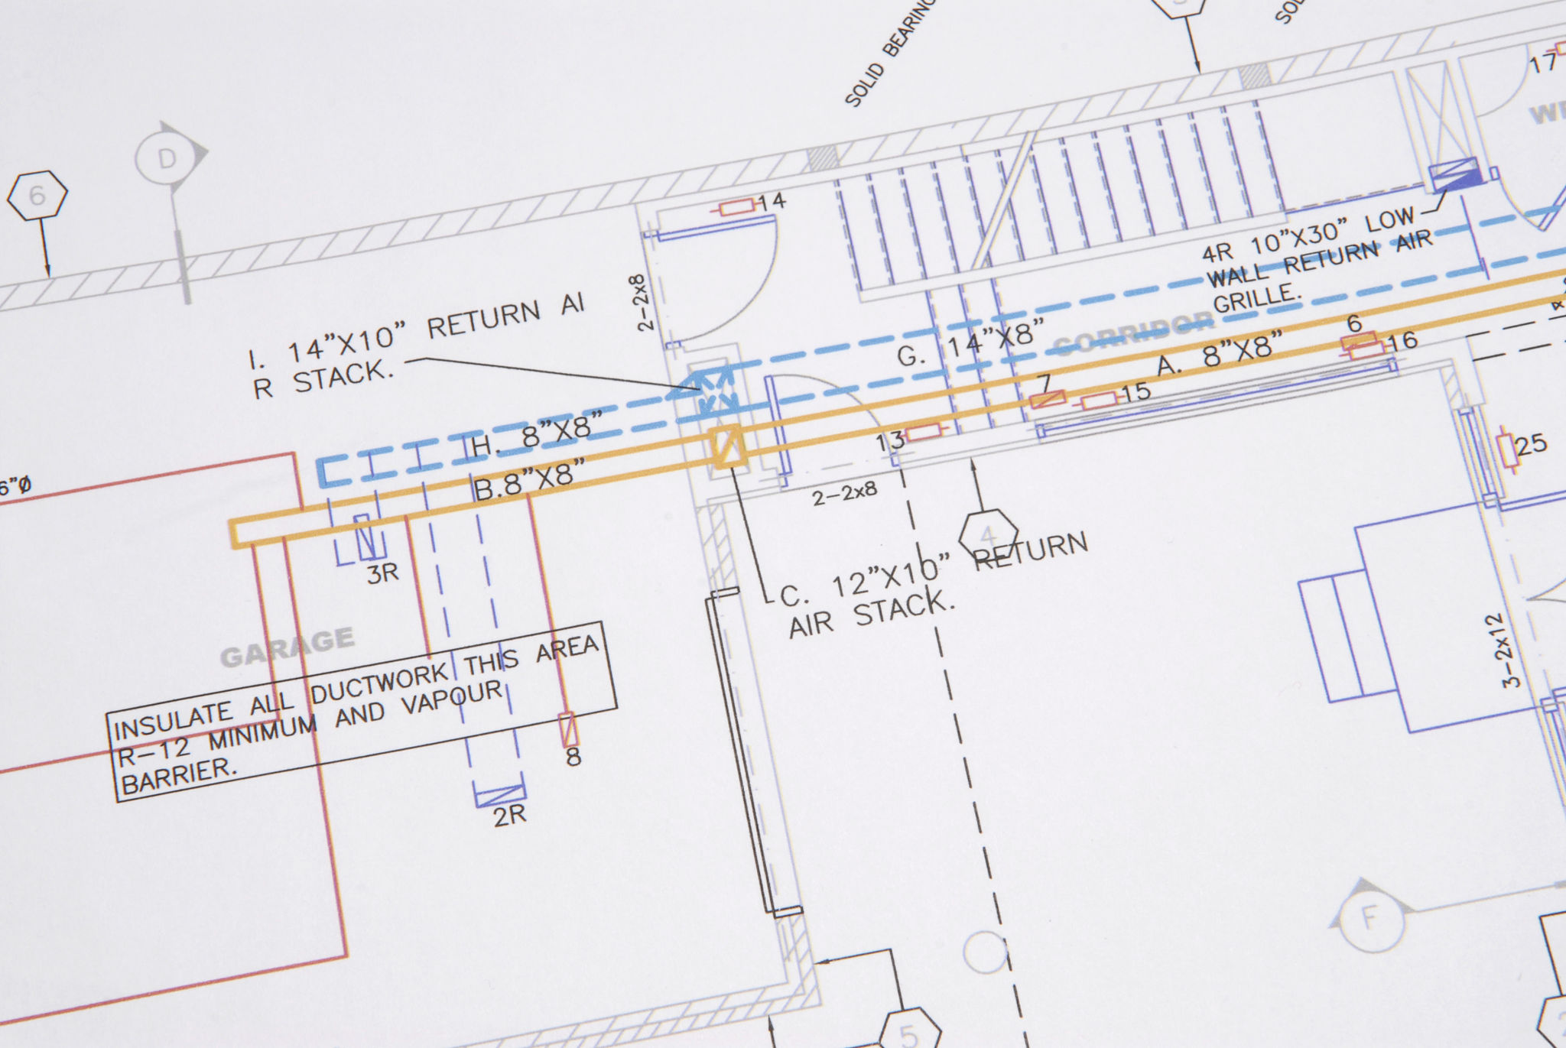

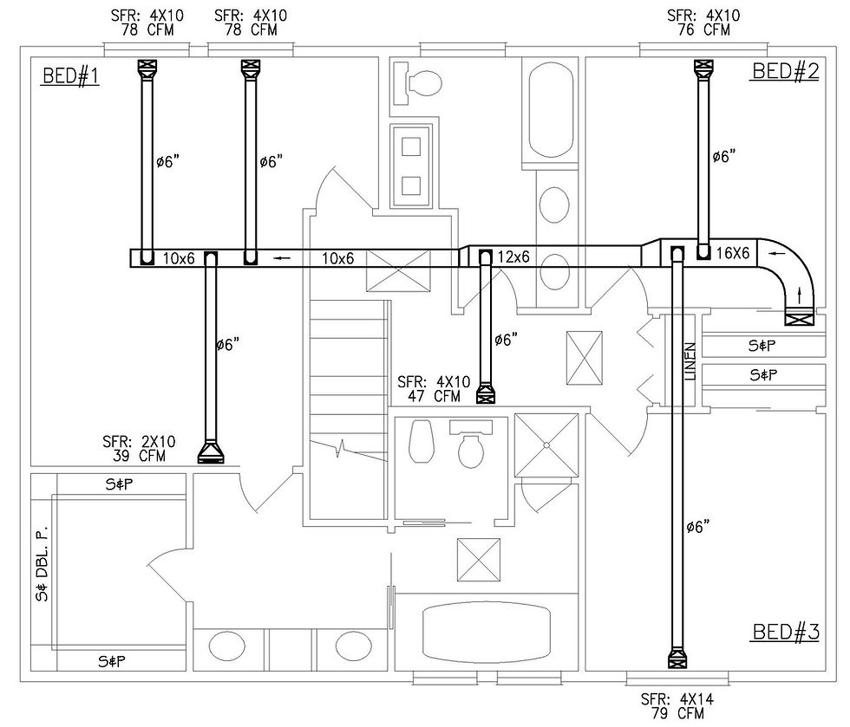



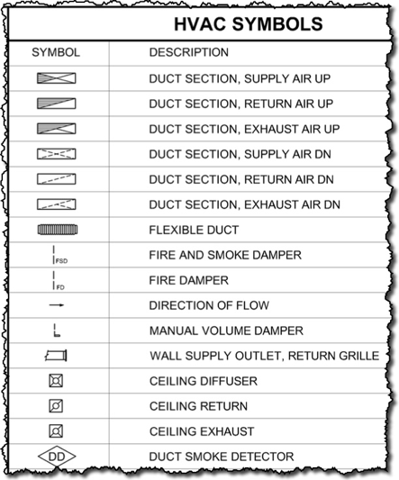

**You must have:**

* Project name, address, jurisdiction
* Plan set date + revision (latest only—no archaeology)
* Mechanical drawings (M-series)
* Specifications (Div 23)
* HVAC legend & notes
* Code references (IECC, IMC, local amendments)

If you don’t have specs, you’re estimating blind. Period.

**2. Building & Usage Data (Drives Sizing)**

* Building type (residential, retail, office, industrial)
* Square footage per zone
* Ceiling heights
* Occupancy loads
* Operating hours
* Insulation values (walls, roof)
* Window types & glazing %
* Climate zone / city design temps

This is what separates “installed” from “works.”

**3. Equipment Takeoff (Big-Ticket Items)**

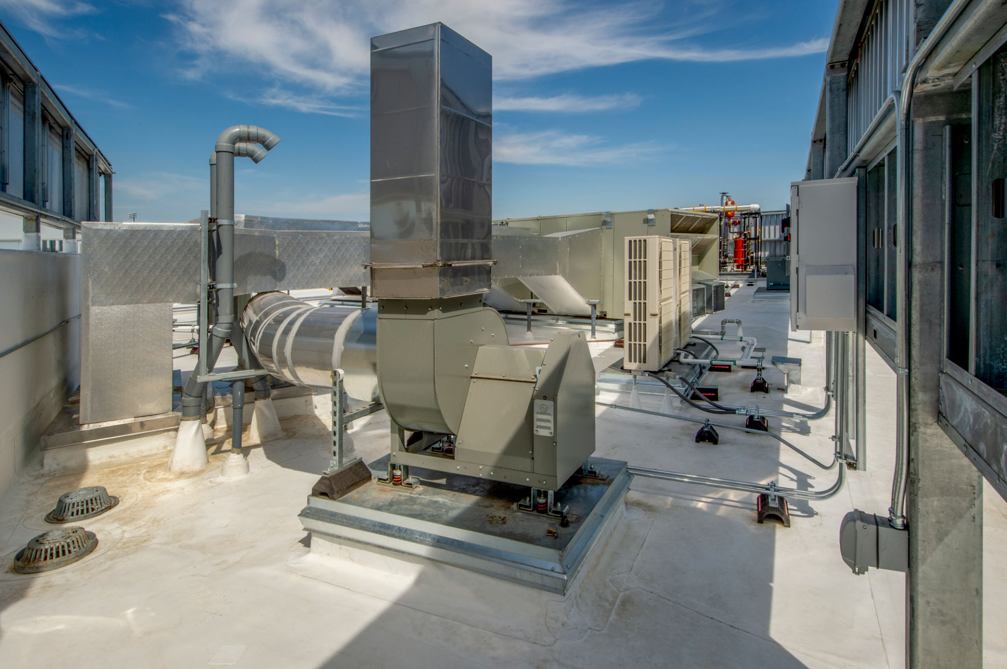

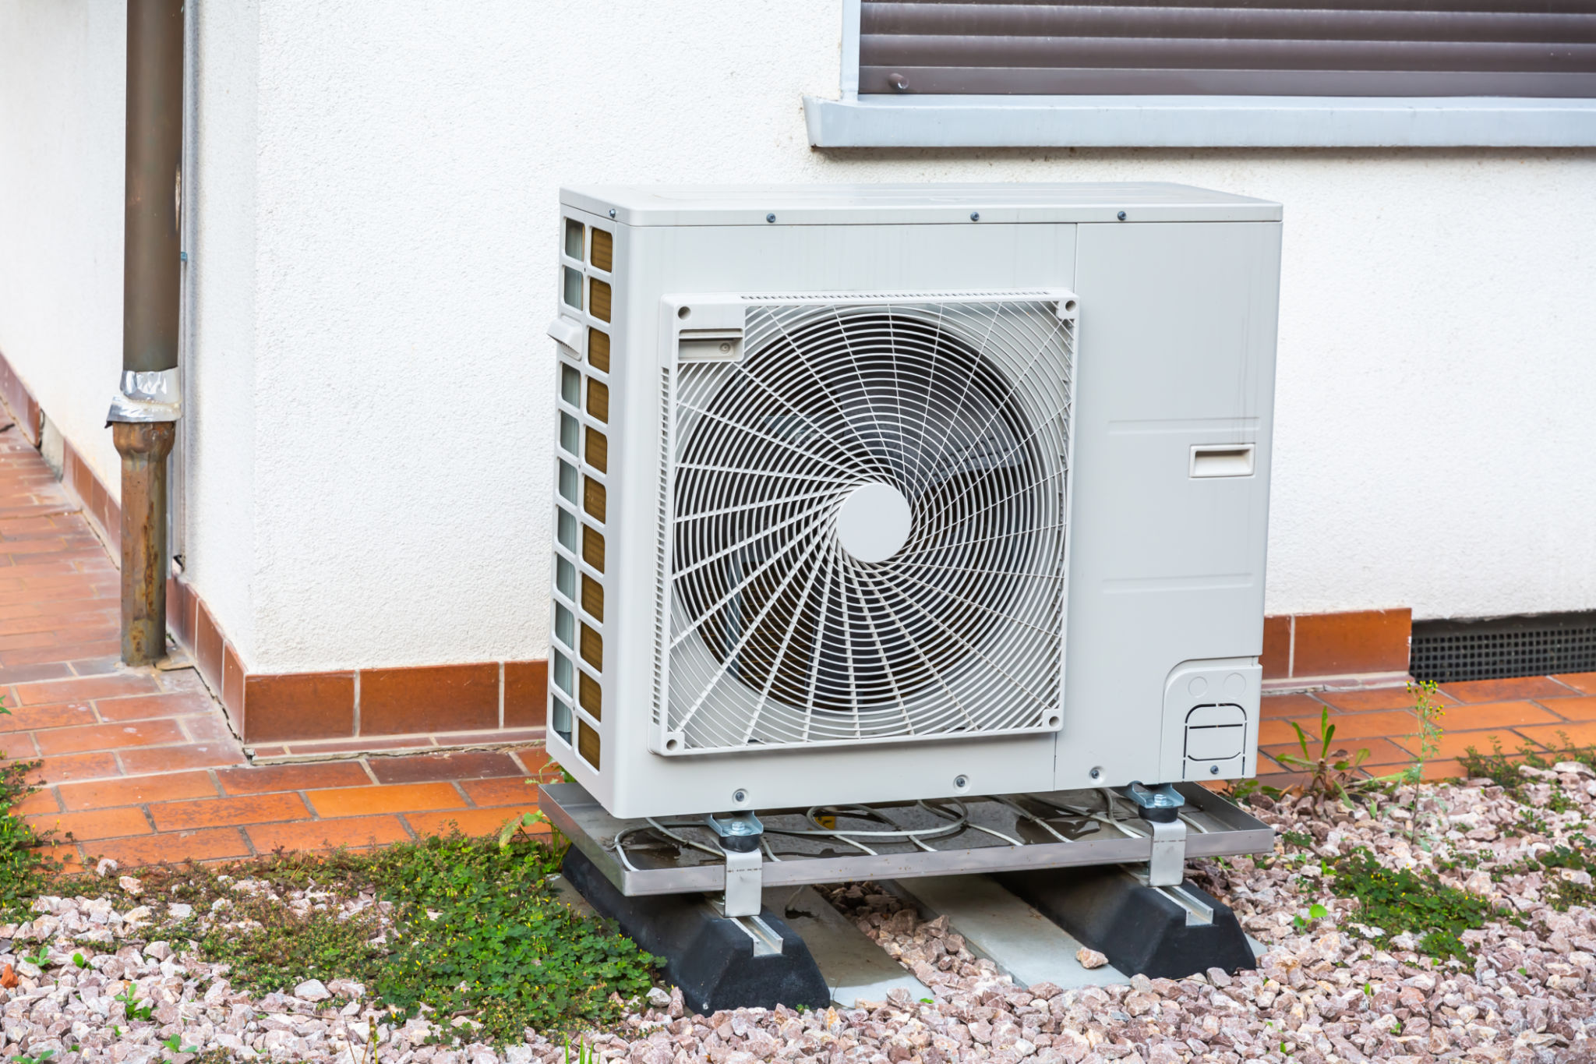

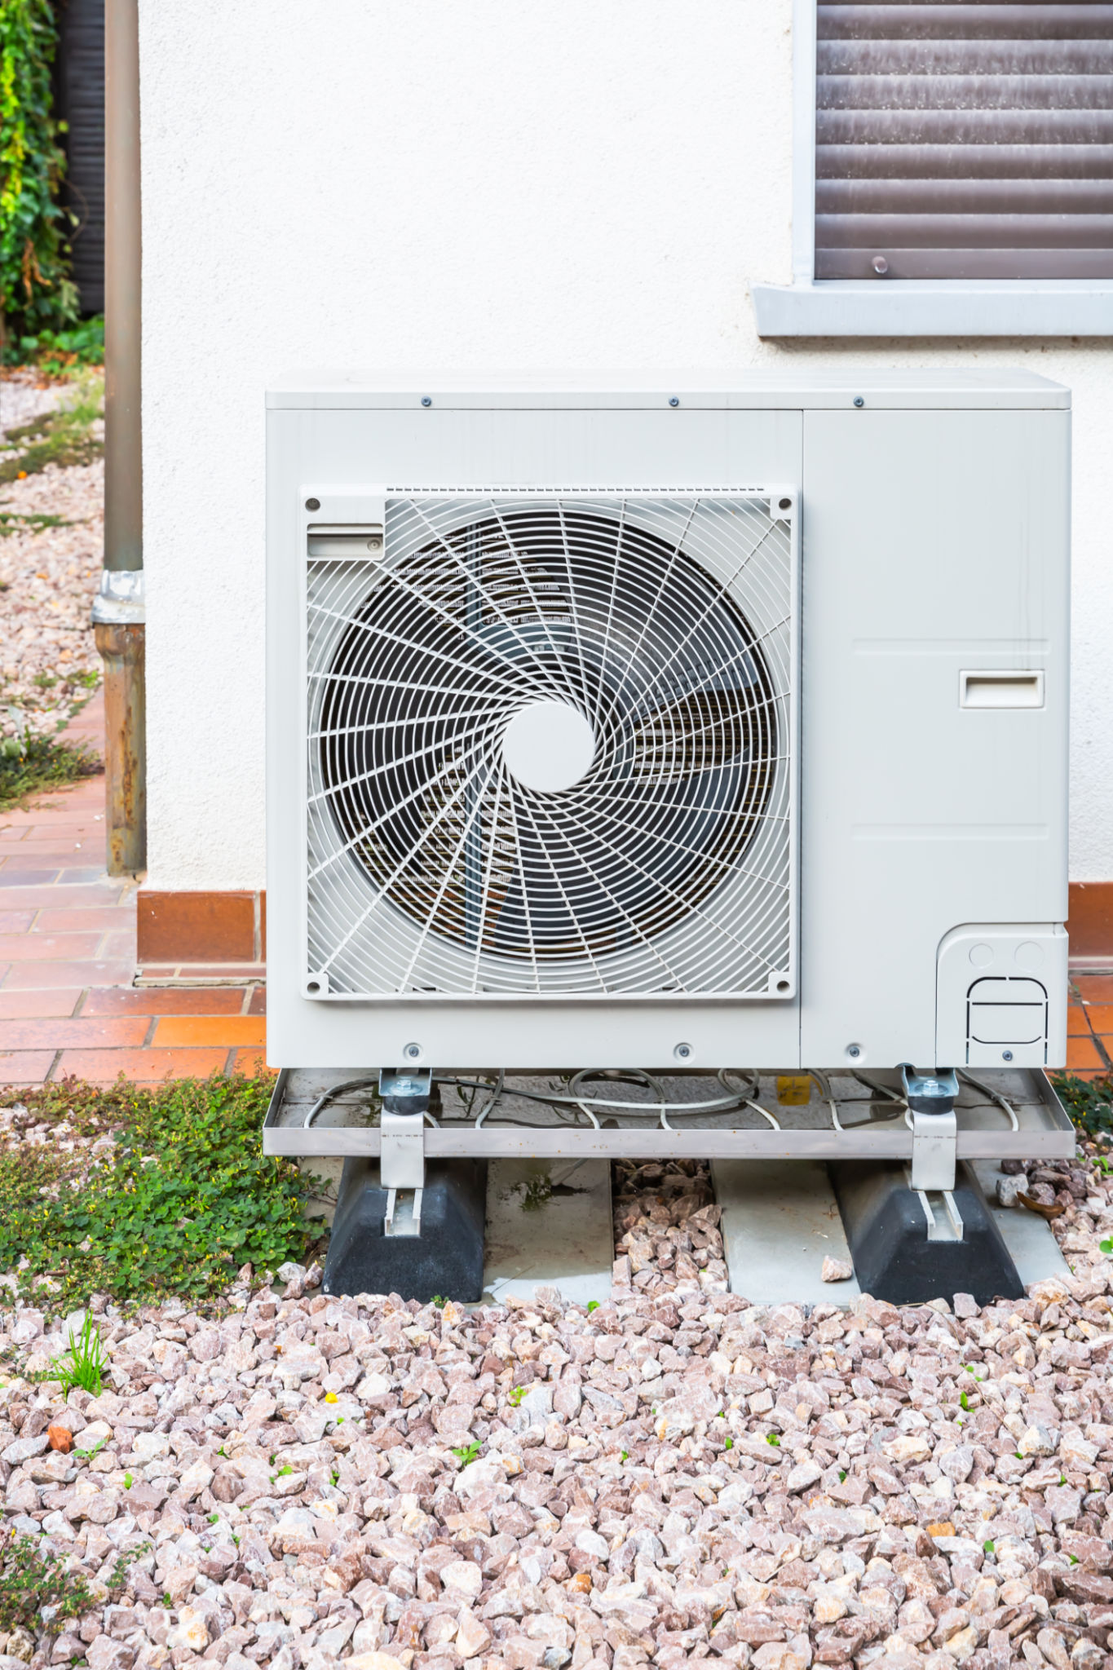

For **each unit**, capture:

* Equipment type (RTU, split system, heat pump, VRF, mini-split)
* Manufacturer (if specified)
* Model number or performance spec
* Tonnage / BTU output
* SEER / EER / HSPF / AFUE
* Voltage / phase
* Gas or electric
* Quantity
* Curb adapters (RTUs)
* Economizers (yes/no)
* Accessories (UV, humidifiers, ERVs, etc.)

If the plan says “or equal,” assume **you’re pricing the equal**, not the unicorn.

**4. Ductwork Takeoff (Where Time & Money Go)**

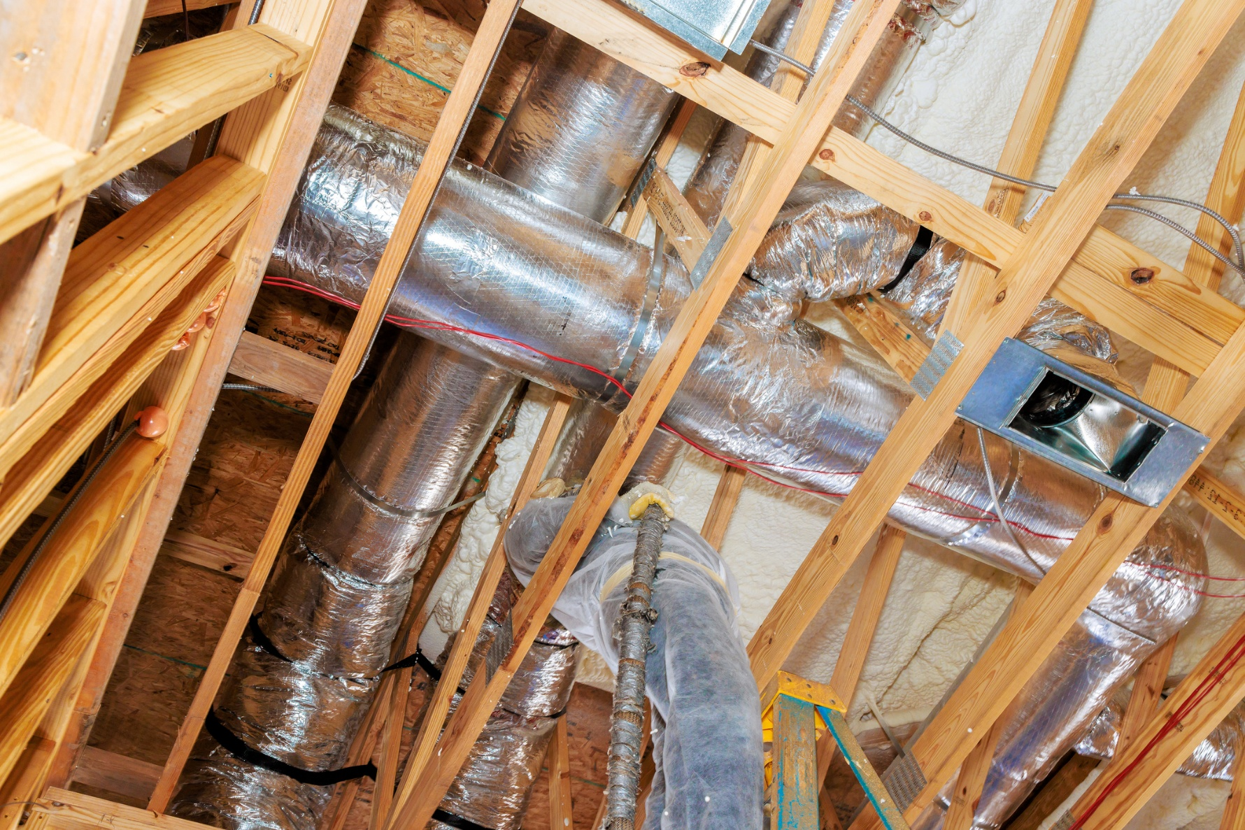

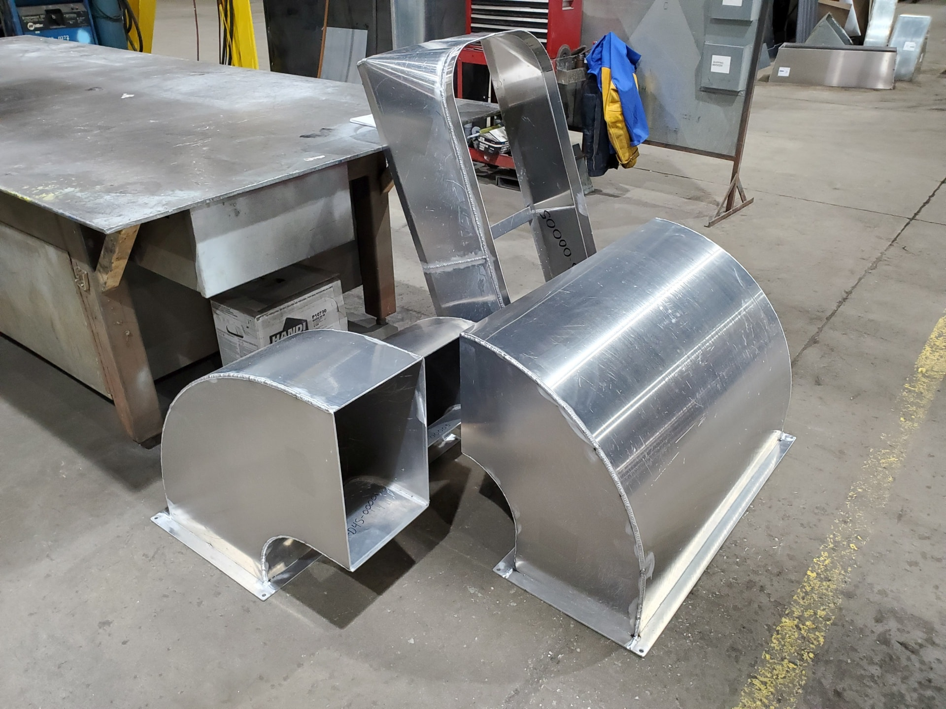

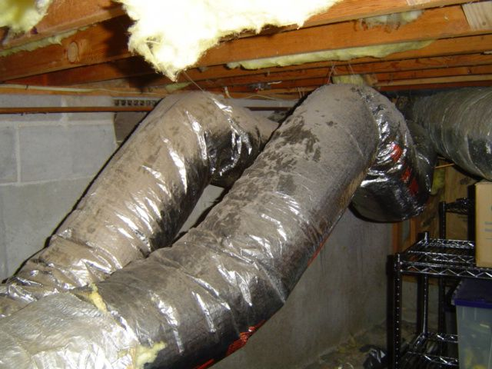

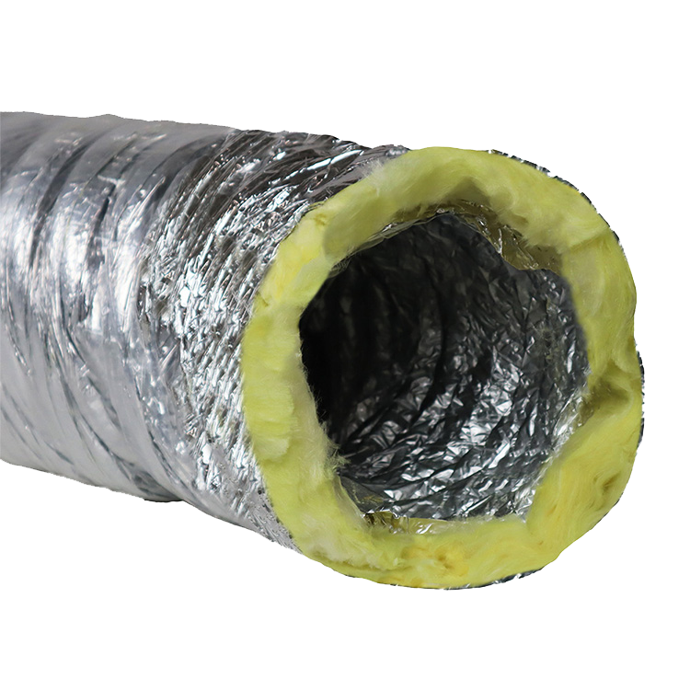

Capture **by size and type**:

* Supply duct (rectangular / round)
* Return duct
* Exhaust duct
* Flex duct lengths
* Duct material (galv, stainless, lined)
* Gauge
* Insulation type & R-value
* Fire/smoke dampers
* Volume dampers
* Turning vanes

Measure **linear feet**, not vibes.

**5. Air Devices & Terminal Units**

* Supply diffusers (type & size)
* Return grilles
* Registers
* Exhaust grilles
* VAV boxes (size, electric or hot water reheat)
* Fan coil units
* Make-up air units

Each one has **material + labor**, and they add up fast.

**6. Controls & Thermostats (Often Underestimated)**

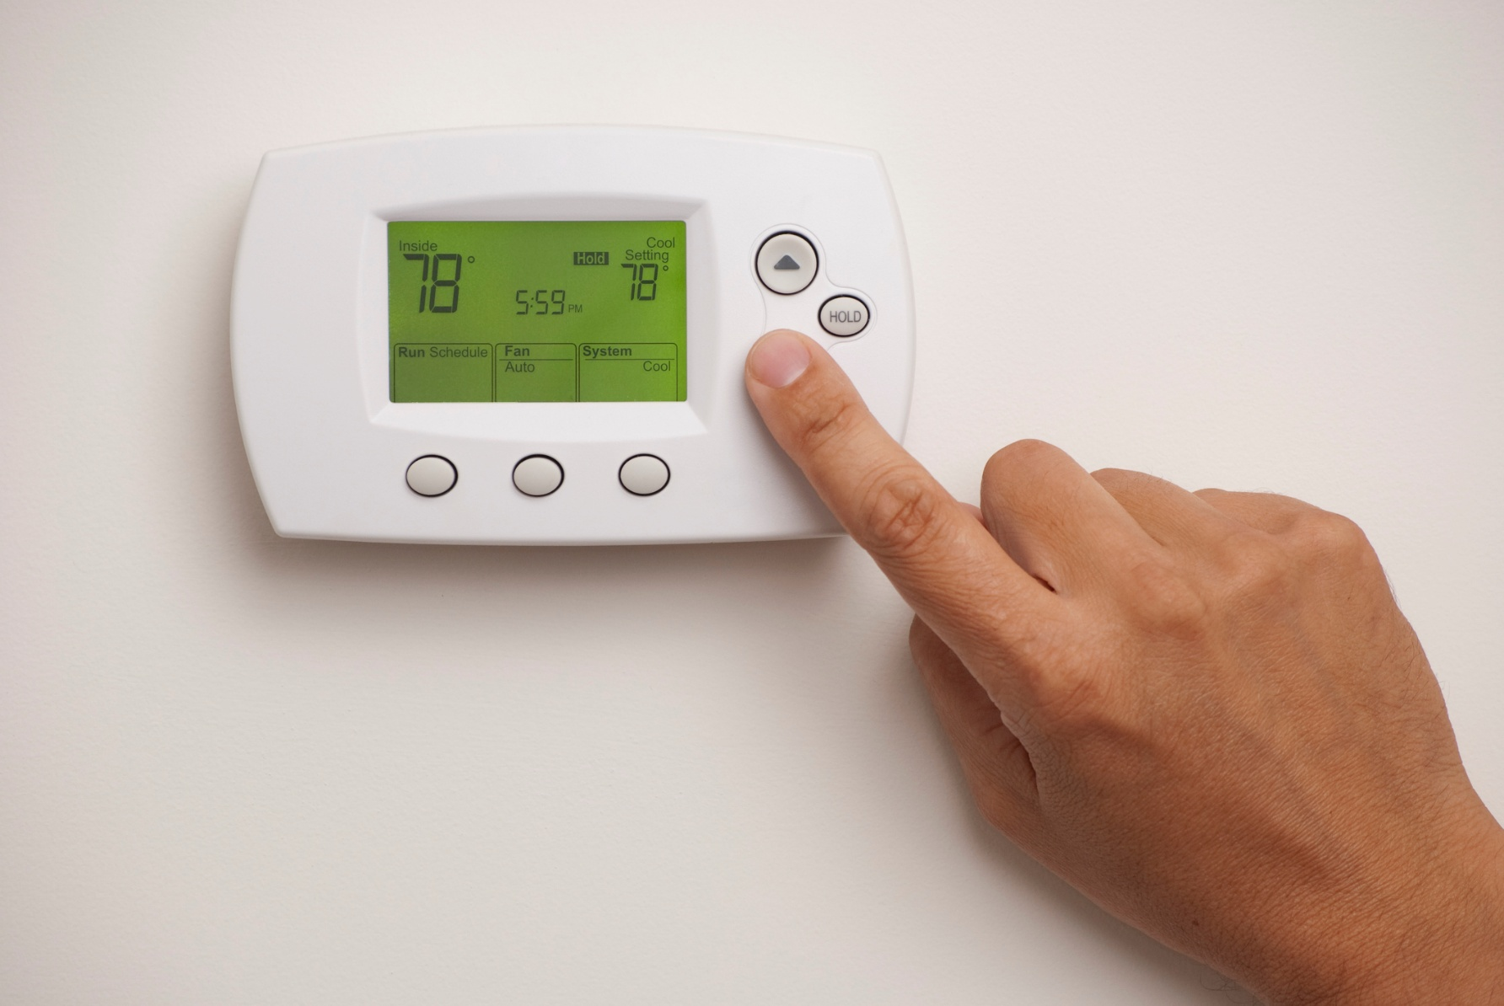

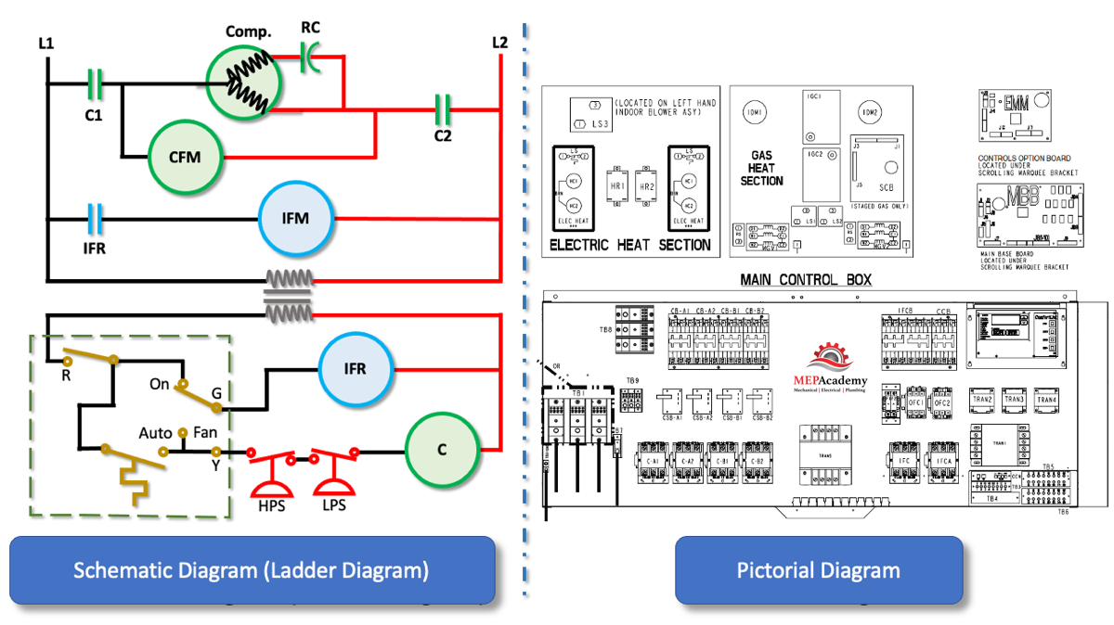

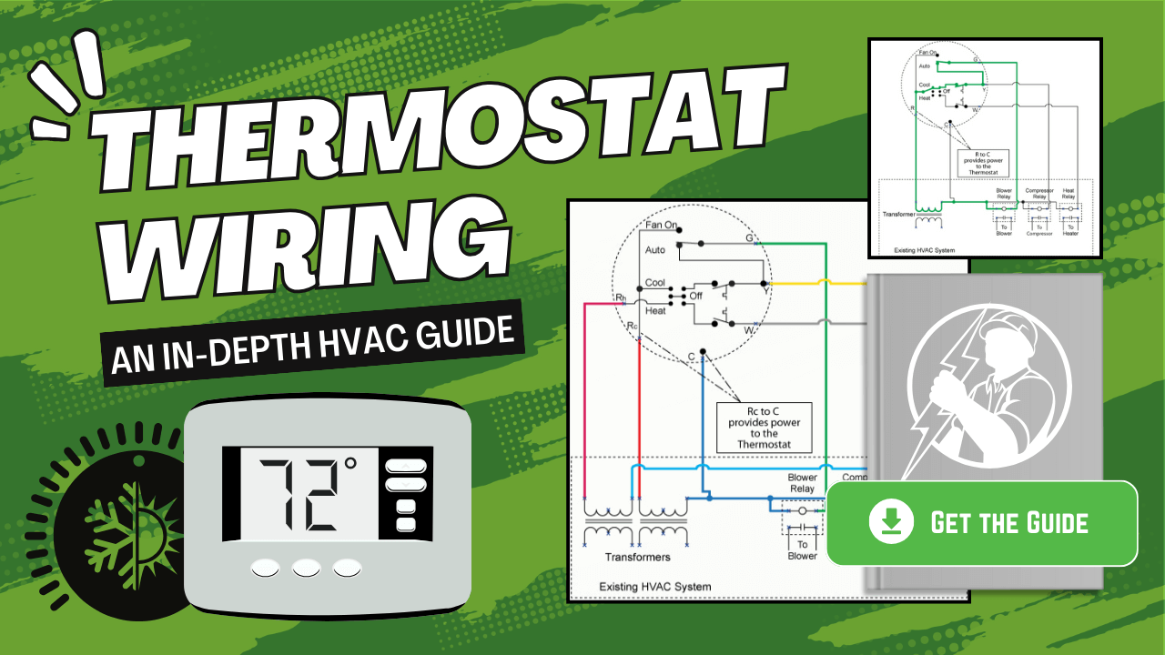

* Thermostat count
* Zoning requirements
* BAS integration (yes/no)
* Control panels
* Low-voltage wiring
* Sensors (CO₂, occupancy, temp)

Controls are where cheap estimates go bankrupt.

**7. Piping & Refrigeration Lines**

* Refrigerant line sizes & lengths
* Condensate drain routing
* Gas piping (size & footage)
* Hydronic piping (if applicable)
* Insulation on piping
* Roof or wall penetrations

Roof penetrations = money. Don’t forget them.

**8. Electrical Coordination (Even If You’re Not Electrical)**

* Unit voltage & MCA/MOCP
* Disconnects
* Starters / VFDs
* Electrical rough-in allowances
* Coordination notes (who provides what)

If you assume “by others” and it isn’t—you own it.

**9. Labor Factors (Reality Check)**

* New construction vs retrofit
* Working height / lifts required
* Phasing or occupied space
* After-hours work
* Weather exposure
* Access constraints

Same duct, different building = different labor. Always.

**10. Code, Testing & Closeout**

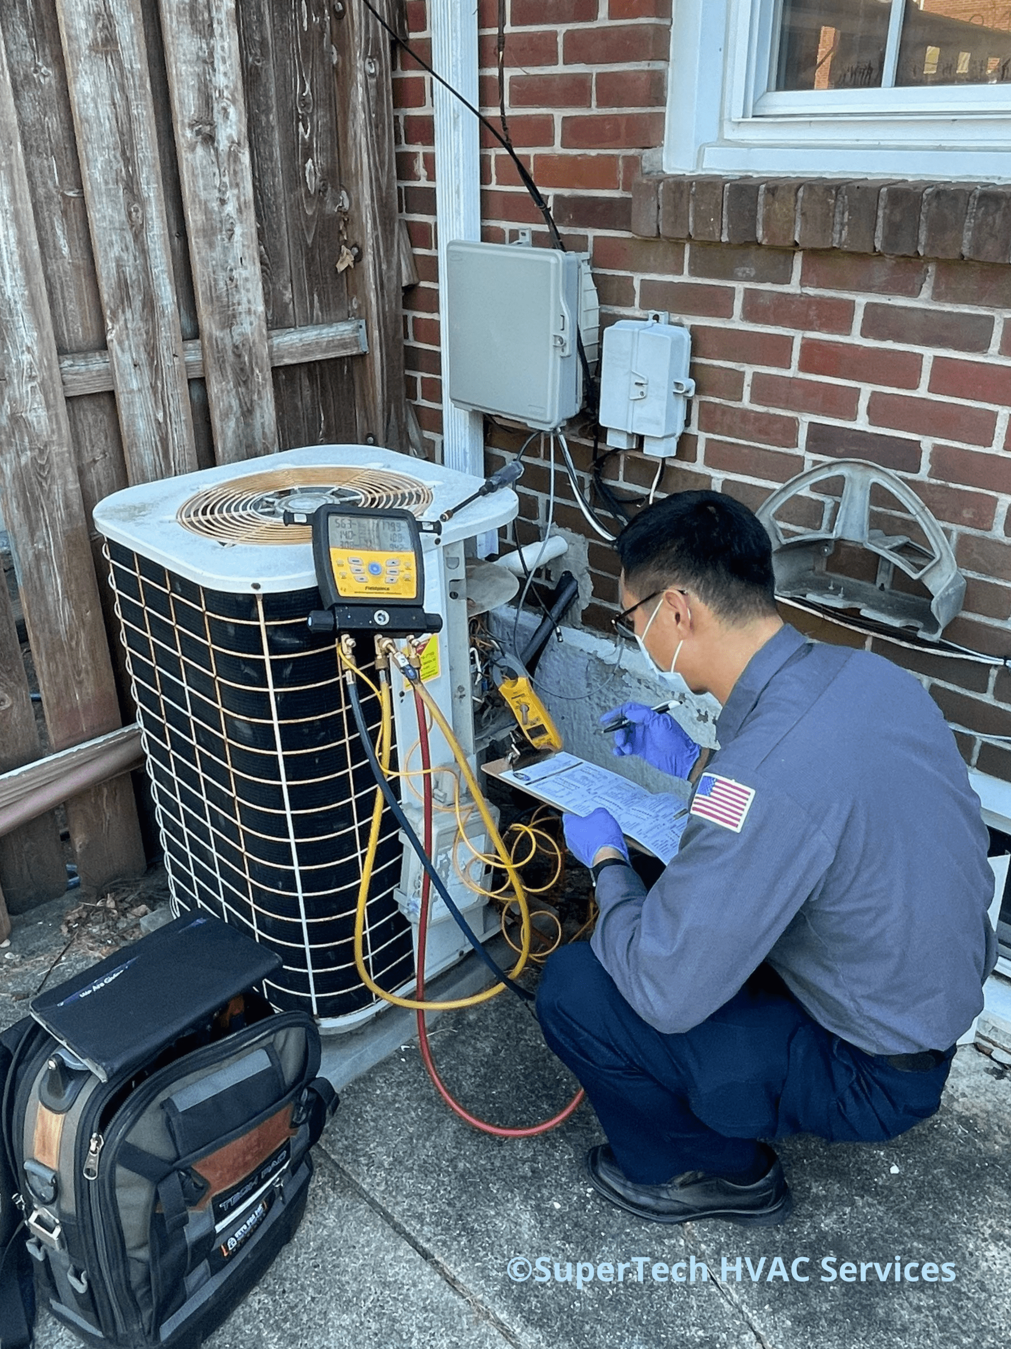



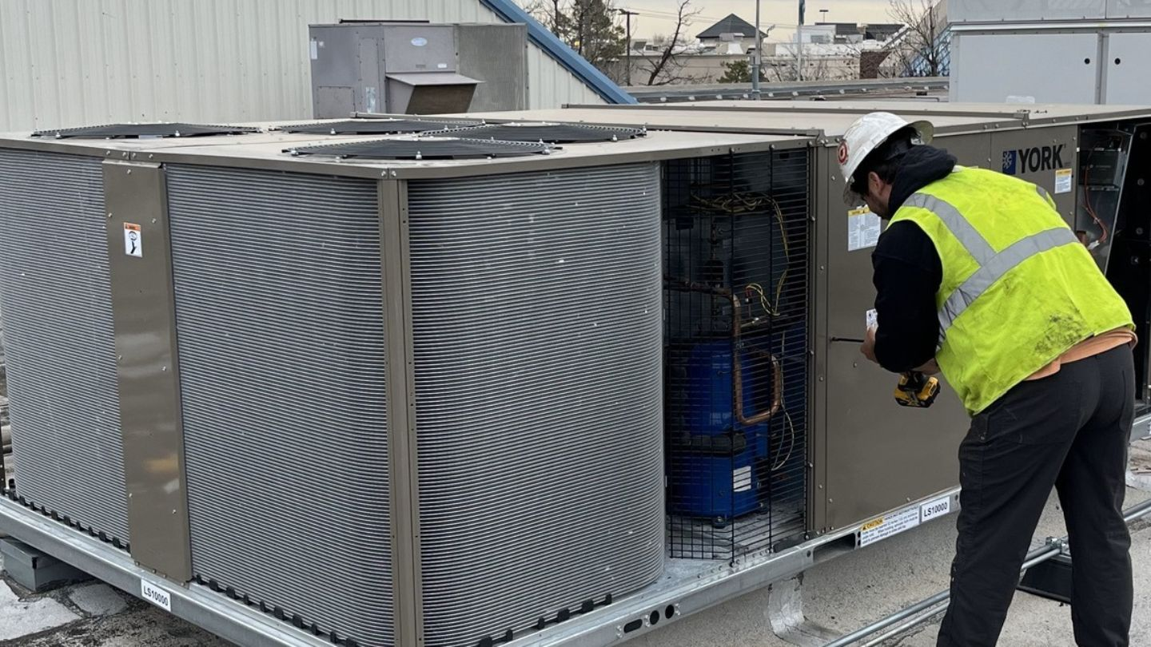

* Permits & fees
* Inspections
* Test & balance
* Commissioning
* Start-up
* As-builts
* O&M manuals
* Warranty requirements

These are not “nice to have.” They’re billable scope.

**11. Exclusions & Assumptions (Save Yourself)**

Always document:

* What is **not** included
* Allowances used
* Owner-provided equipment
* Utility company work
* Structural modifications
* Fire alarm integration

If it’s not written, it’s your fault later.

**Bottom Line (No Sugar-Coating)**

A proper HVAC takeoff is:

* **40% reading plans**
* **40% measuring**
* **20% covering your backside**

If you want, next we can:

* Build this into an **Excel takeoff template**
* Convert this into a **blueprint → AI-assisted HVAC takeoff workflow**
* Or tailor it specifically for **residential, commercial TI, or multifamily**

Just say which direction you want to go.